First Class Inclusive Collaborative Forward-thinking
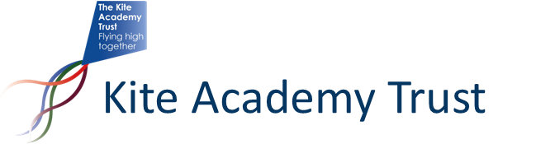
TRAINING COURSE BOOKING CONDITIONS
Please note the following:
- Places will be allocated on a first come first served basis; if you are not able to book online, please contact training@kite.academy to be added to a waitlist.
- A cancellation charge of 50% of full cost per place will be made for any bookings cancelled up to two weeks before the event; after this date, the cancellation charge becomes 100%. This may be negotiable if the place can be filled.
- All attendees are expected to adhere to our COVID safe procedures (see below).
All delegates are asked:
- Not to attend if they are displaying any COVID symptoms or are expecting to be self-isolating (please contact the organiser and arrangements will be made, where possible, to move you to an alternate date);
- To follow current Government and Academy PPE guidance relating to any local COVID outbreaks;
- To ensure they practice good hand hygiene prior to any practical activity or addition of a new partner (washing hands on arrival and using hand sanitiser prior to each practical session as a minimum);
- Where required, to use the PPE provided by the trainer.

